Sensory Behaviour checklist for school and classroom

Name: | DOB:
Date completed: | Class:
School: | Completed by:

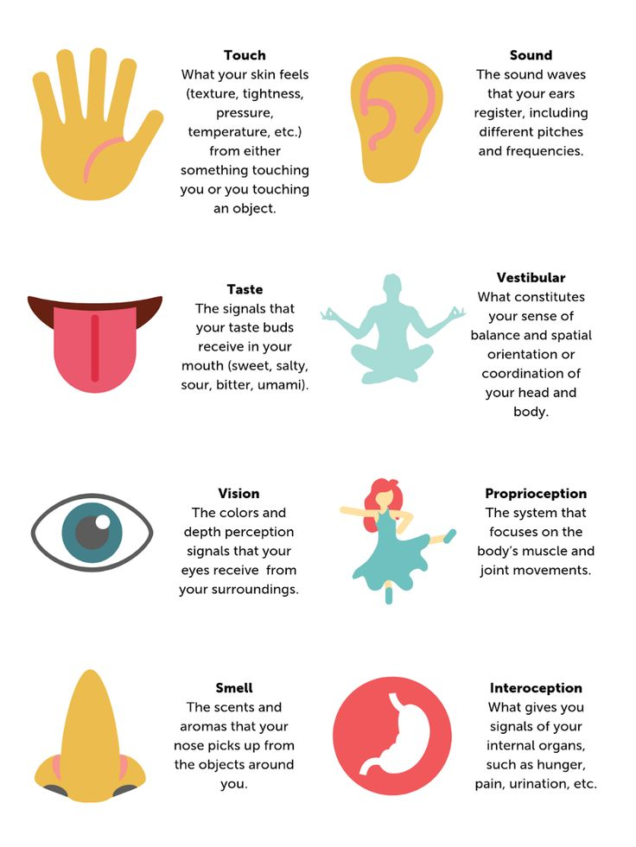
What is Sensory Processing?

Sensory processing is what makes it possible for a CYP to use the sensory input he/she is receiving from their body and environment in a functional, adaptive manner. Effective sensory processing is necessary for almost every activity a CYP performs. We must be able to integrate the information we receive from all our senses to understand our surroundings successfully.
A CYP with sensory processing concerns has difficulty using sensory input from his/her eyes (vision), ears (sound), skin (touch), nose (smell), mouth (taste), muscles and body joints (body awareness), and inner ear (balance & position of body in space).
To find out more about the senses please attend understanding sensory processing and supporting sensory processing school/nursery prior to using this resource. https://www.buckshealthcare.nhs.uk/cyp/

Sensory processing organises the sensations from one’s own body and the world around us. For some children, their sensory integration does not develop as it should and may affect their sight, hearing, smell, touch, taste or spatial awareness. Children can experience hypersensitivity (excessive and undesirable reactions) or hyposensitivity (under-responsive and difficulty in processing responses) to stimuli. This checklist aims to identify sensory processing issues. It is not a diagnostic tool and professional advice should be sought. Also bear in mind the child’s age, developmental stage and ability. Highlight all that apply

Proprioception – Input / feedback informing movement, body position, weight, movement, spatial awareness
Under responsive – please note you are unable to be over responsive to proprioception.
Unable to keep still, very fidgety, craves movement
Often sits in a W position on the floor.
Poor fine motor skills
Walks on toes or stomps feet
Likes jumping / trampolining / bouncing on furniture
Difficulty turning handles, opening and closing items.
Enjoys bear hugs (on own terms)
Rocks, spins, flaps, takes risks
Loves rough / tumble play, tackling / wrestling games/roughhousing.
Likes tight and small spaces.
Has sleeping difficulties.
Difficulties manipulating small objects - tying laces
Clumsy, everything is done with too much force
Enjoys falling off objects
Likes being wrapped in blanket / firm touch / massage
Grinds teeth
Frequently cracks knuckles.
Exerts too much pressure when handling objects.
Excessive banging of toys and objects.
Unaware of personal space / body position in space
Wears clothes (belts, shoelaces) as tight as possible.
Difficulty regulating pressure when writing or drawing, presses too lightly or too hard.
Often rips paper when erasing, pushing too hard.
May not understand how heavy or how light.
May love pushing, pulling or dragging objects.

Vestibular – Contributes to our balance system (inner ear) and our sense of spatial orientation
Over responsive  Fear of heights  Fear of lifts / escalators walking upstairs / uneven surfaces  Avoid feet leaving the ground.  Dislikes head being tipped back (washing hair)  Dislikes sudden movement / anxious if moved suddenly  Fears challenges to balance (being pushed / falling),  Dislikes playground equipment, ladders, slides, swings  Avoids active games (PE) avoids games requiring balance, hopping, jumping.  May have difficulty riding a bike.  Travel sickness  Dislikes stop and start of car  Dislikes change of position, avoids rapid or rotating movements. | Under responsive  Rocks, spins, hops, runs or bounces rather than walks  Cannot keep still, i.e.; shakes leg, moves head, rocks body when seated.  Like fast rides  Likes roundabout  Spins self, possibly for hours and does not get dizzy  Enjoys being thrown in air  Enjoys rough and tumble  Seeks balancing activities  Likes climbing  Poor balance  Loves to swing as high as possible.  Is a thrill seeker and can be dangerous at times?
Visual – sensitivity to lights, difficulty focusing, distracted by stimuli.
Over responsive  Child covers eyes / withdraws from bright lights  Avoids certain / bright colours  Gets headaches from lights / reading / watching TV  Looks down to the side or out of corner of eyes.  Focus on detail  Pays attention to small details  Poor/or avoids eye contact  Prefers dark areas / playing in the dark  Avoids looking at TV or computer screen  Difficulty matching / sorting objects  Seems not to see objects on busy pictures  Constantly scans visual information  Finds coloured lenses useful when reading | Under responsive  Has difficulty distinguishing certain letters – p/q. b/d, x/+  Makes reversals in words – saw/was, no/on  Loses place when reading or doing maths problems  Difficulty in seeing different colours, shapes, sizes  Craves bright, colourful and cluttered spaces.  Seeks bright lights / flickering lights  Likes shiny objects / colourful resources  Rubs eyes hard / inappropriate staring  Uses peripheral vision / sees double  Watches repetitive movements  Enjoys flicking lights on and off  Like watching sand falling and water  Lines up objects  Likes looking at spinning/shiny objects.  Flicks fingers/hand/toys in front of eyes.
Tactile – sensitivity related to touch, pressure.
Over responsive  Pulls away from light touch / avoids holding hands  Avoids crowded situations.  Dislikes certain textures / removes clothes  Avoids messy activities.  Resists having teeth brushed / nails or hair cut / brushed  Likes labels cut out of clothes  Does not like getting hands or body wet  Dislikes wearing shoes / socks / hats / gloves  Dislikes being dried by a towel / being tickled  Low pain threshold  Gets fearful, anxious or aggressive with light or unexpected touch.  May become frightened when touched by someone/something that they cannot see.  May avoid group situations and/or sporting activities.  Avoid being out in windy weather, or when raining.  May get distressed by dirty hands/face.  May avoid wiping after toileting.  May refuse to wear socks/shoes.  Walks on toes on new flooring/textures. | Under responsive  High pain threshold  Excessively touches objects  Seeks messy play.  Likes to touch/stroke objects/surfaces/textures  Needs to fiddle  Likes pressure  Has trouble keeping hands to self  Cannot feel changes in temperature / wind on their body  Plays rough and tumble and aggressive games  Unaware of hurting others whilst playing  Gets frustrated when buttoning or unzipping clothes  Not aware if being touched/bumped into unless done with intensity.  Can be heavy handed, too much force used when around children/pets when playing.  Craves vibration.  Self-harming i.e., may pick skin.
Oral Input – sensitivity to taste, food preferences, oral stimuli.
Over responsive  Only eats certain foods, picky eater  Eats small range of foods, even certain brands  Hesitant to try new foods / flavours / textures  Drinks through a straw or special bottle  Likes bland food / ‘beige’ food  Refuses new food, may only eat soft food  Sensitive to eating hot or cold foods  May gag at some textures of food.  Complains about spicy, salty, sweet sour food  Does not like brushing teeth/taste of toothpaste.  Fears going to the dentist | Under responsive  Will put non-food objects in mouth past the age of two.  May bite.  Eats very quickly  Likes excessively spicy, sweet, sour or salty food  Excessive drooling  Chews on hair, shirt, fingers  Has difficulty sucking, chewing and swallowing.  Acts as if all foods taste the same  Demands sauce, condiments and seasoning on food  Make seek vibration to the mouth i.e., loves vibrating toothbrushes
For children with a limited diet please list the food they will eat:

Oral Motor – tactile sensitivity of the mouth.
Over responsive  Dislikes or avoids fizzy drinks  Dislikes or avoids chewing food  Avoids crunchy food  Dislikes having teeth brushed  Dislikes fork / spoon | Under responsive  Likes to chew – may chew edible and inedible objects  Likes to teeth grind  May bite cheek, tongue or lips  May chew pencils or fingers  May overfill mouth with food, swallow large chunks
Auditory-Language – sensitivity to sounds, speaking, difficulty with spoken sounds.
Over responsive  Does not like loud noises but makes own ‘loud’ noises  Unable to locate the source of a sound  Can hear sounds others are not aware of  Puts fingers in ears  Puts hands over ears  Hides under table  Speaks in really quiet voice  Gets tired | Under responsive  Shouts  Talks off topic  Talks out loud  Sings / talks inappropriately  Hums / sings / talks to self  Unaware of sounds or where they come from  Difficulty recalling / repeating / speaking articulately  Gets tired
Olfactory – sensitivity to smells, difficulty identifying odours, associates people / places / object with smell.
Over responsive  Avoids areas of school / home  Bothered by smells that do not bother others  Offended by bathroom smells  Tells other people how bad, or how funny they smell.  Covers nose  Refuses certain foods (see taste). | Under responsive  Seeks certain smells  Finds discriminating unpleasant odours  Puts unpleasant smelling objects into their mouth  Cannot smell scratch’n’sniff stickers  Smells objects / people  Will excessively use smell to familiarise themselves to when introduced to new foods, people, objects, and places.
Activities of Daily Living – please tell us if you child has any specific difficulties with the occupations below:

Getting washed
Brushing their teeth
Getting Dressed
Eating and Mealtimes
Sleep
Being able to learn in the classroom
Being able to play in the playground
Are there any behaviours that cause harm to self or others?

To book an advice line or to return the questionnaire please use the contact details below
www.buckshleathcare.nhs.uk/cyp/therapy/occupational-therapy
01296 838 8000
Buc-tr.cyptherapies@nhs.net

